MSN (Microsoft-Network) Messenger and Netmeeting

Installation of all programs
First of all you have probably to install MSN-Messenger. You can get it by downloading from http://www.msn.com (Downloads) or http://messenger.msn.com in your language.
Then you have to register to get a hotmail-address. The program will guide you. If it doesn’t work you can get a hotmail-account at http://www.hotmail.com ; remember your name and password for further reference!
Then you have to make yourself familiar with the messenger program. You should add me to your contact-list by searching for deceanu@hotmail.com .
If this is done and we both are online we can chat with MSN-Messenger by clicking on my name and sending an instant-message. This was the first step.
Then – offline – you should start the program “Netmeeting”. You find it at Start-Programs-Add-ons-Communication-Netmeeting. At Windows 98 or ME it is installed.
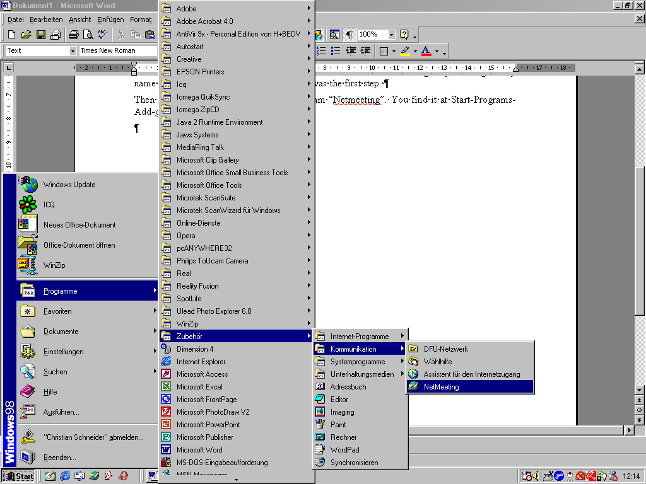
At the first time there will appear an installation-assistant. It will guide you through the setup-process. Be sure that you have connected all your devices as web-cam, microphone etc. I recommend you to use an extern microphone or a headset.

Using Netmeeting
You must be online and MSN-Messenger started. When you chat with a friend you can invite him to use Netmeeting. All your devices as web-cam and microphone must be ready to use. Click at the Messenger only at “Start Netmeeting”. When you get an invitation click “Accept”.
Then Netmeeting will start and stabilize the connection. It will look like this:
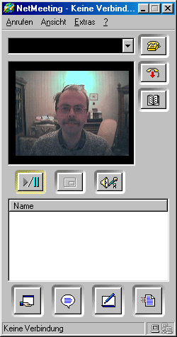
Start/Stop Video.
Picture in picture-mode (recommended for beginners).
Start chat.
The field for the IP-Address, e.g. 212.143.26.71
When you cannot establish a connection via Messenger you can do the following: go to help-info and look up your IP-Address. Then send it via e-mail or Messenger to your friend. He will type the IP-Address in the field listed above. So Netmeeting can connect. You should know that in general you don’t have a fix IP-Address. It changes everytime you make a new dial-up-connection to the Internet.
I wish you much success! If you have questions you make contact me at schneider@gmx.at .
Yours,
Christian Schneider

