I.) XC16x Board:

Please refer to the XC16Board Hardware Manual.

- Power Supply

The XC16x Board requires an external power supply.
A regulated DC power supply from 9 to 12 Volts can be connected to the power connector.

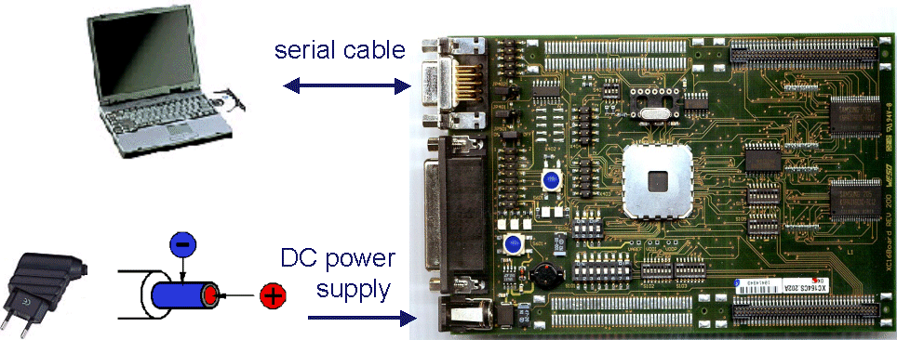

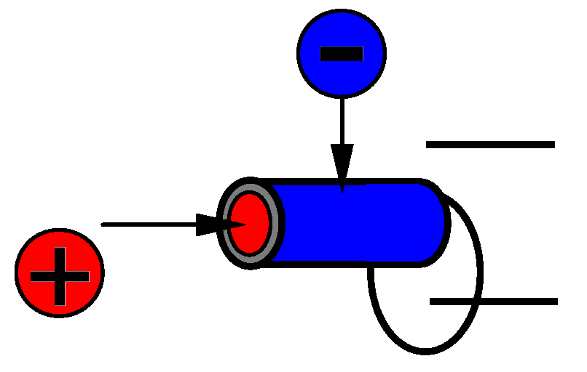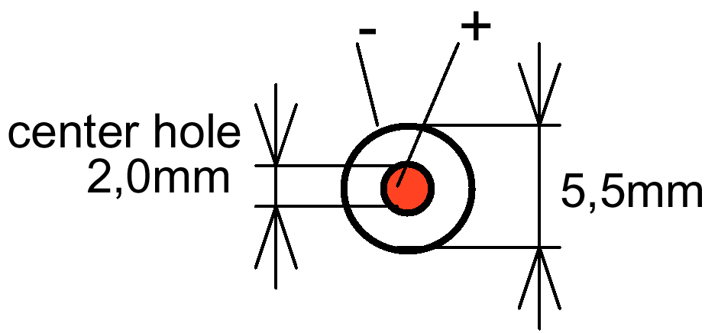
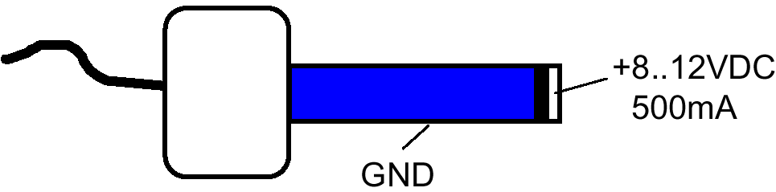

- Bootstrap Loader ⇔ Standard Internal Start

