IV.) Using of the KEIL - µVision 2 Development Tools:

- Step: – Install the Tool chain - here you can download the Keil Development Tools:

http://www.keil-compiler.de/c166/
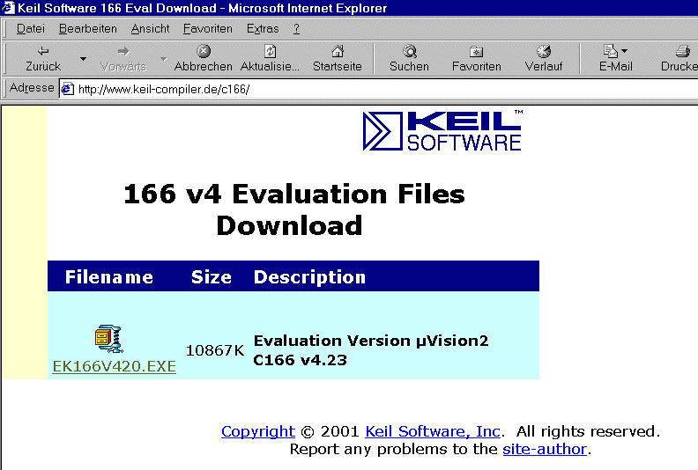

Execute ek166v423.exe and choose C:\KeilDemo for the installation path

- Step: Start Keil µVision and open the DAvE Project

If you see an open project – close it: Project - Close Project
Project - Open Project
choose: C:\e10k
choose: File type: Dave Project Files
choose: e10k.dpt

Open
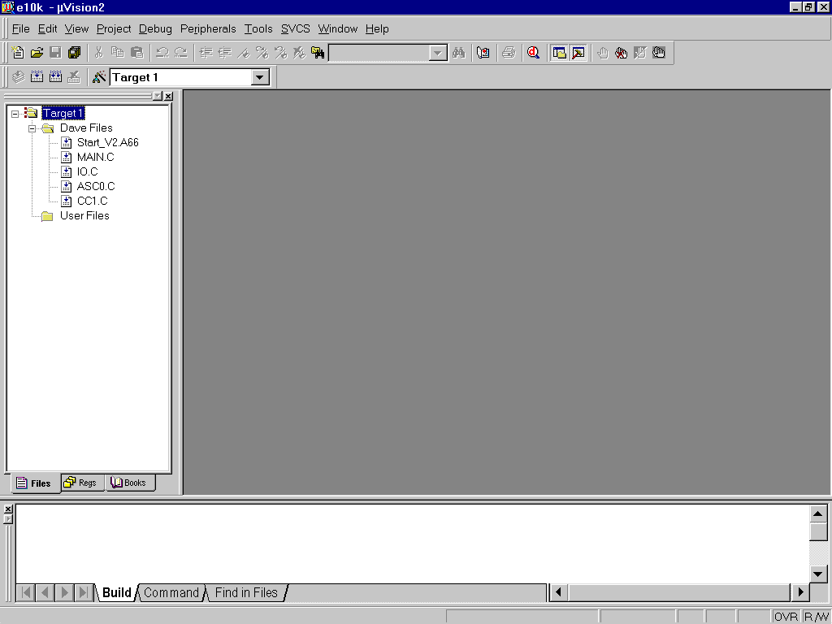

- Step: include the DAvE Header Files

mouse position: Files window: Dave Files: click right mouse button

Add Files to Group ´Dave Files‘
input filename *.h
mark Asc0.h Cc1.h Io.h Main.h

Add

do this 4 times:
Type: choose: Custom file
OK

Close
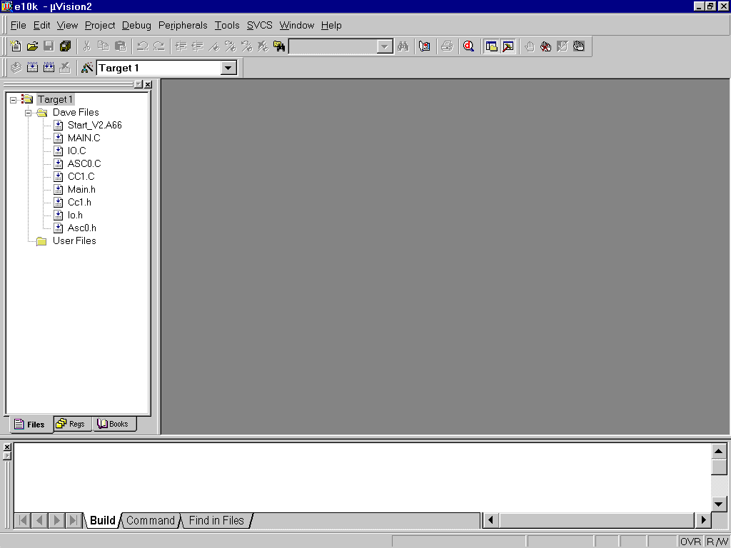

- Step: include the ConfPLL+Syscon3.c File

mouse position: Files window: User Files: click right mouse button

Add Files to Group ´User Files‘
input filename *.c
mark ConfPLL+Syscon3.c

Add
Close
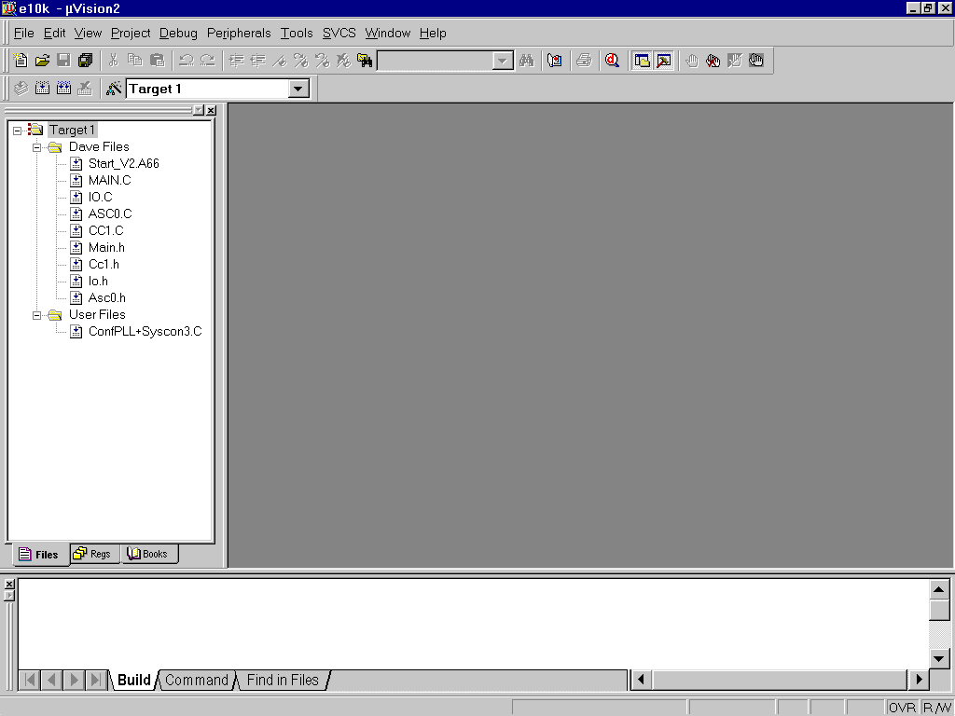

- Step: Configure the Options for the Header Files:

right mouse button click Main.h

Options for File Main.h
click □ Include in Target Build
click □ Always Build
click □ Link Publics Only

OK
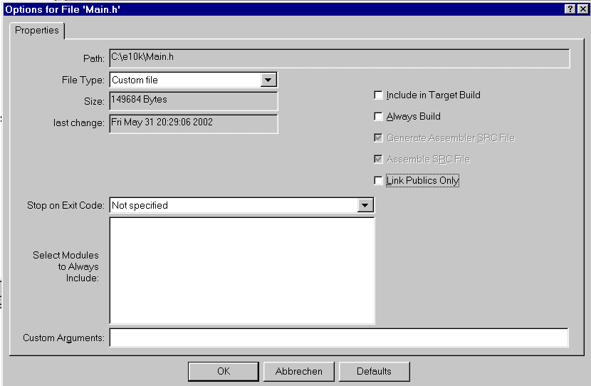

repeat this for the header files Cc1.h Io.h Asc0.h
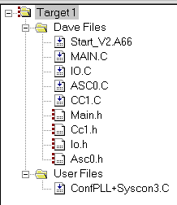

- Step: Configure Compiler, Assembler, Linker, Locater, Hex-Converter and Build – Control:

right mouse button (Files window) click Target1

Options for Target ´Target1‘

click ✓ Use On-chip XRAM
External Memory #1: select ROM, insert Start: 0x0C00000, insert Size: 0x20000
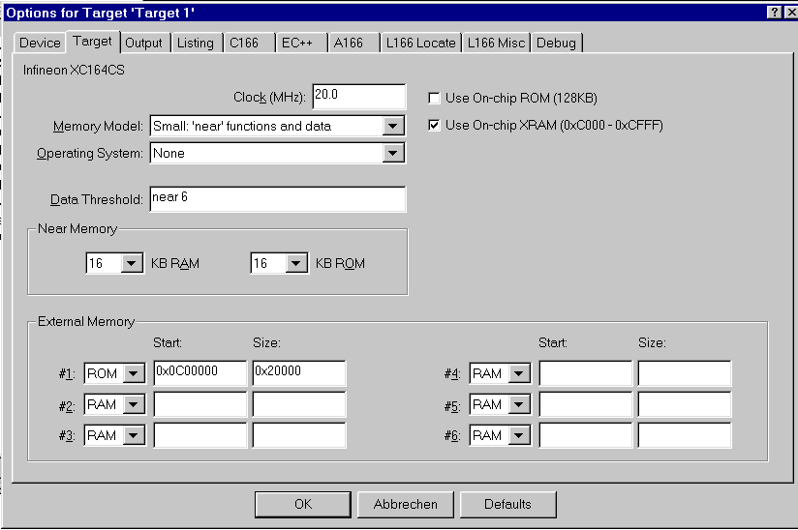

Output: click ✓ Create HEX File, choose HEX Format HEX-386(H167)
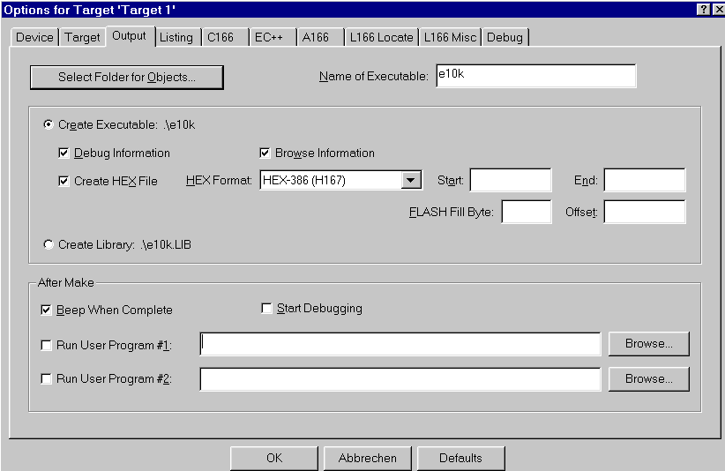
Listing (do nothing)
C166 (do nothing)
EC++ (do nothing)
A166 (do nothing)
L166 Locate (do nothing)

L166 Misc: insert Interrupt Vector Table Address 0x0C00000
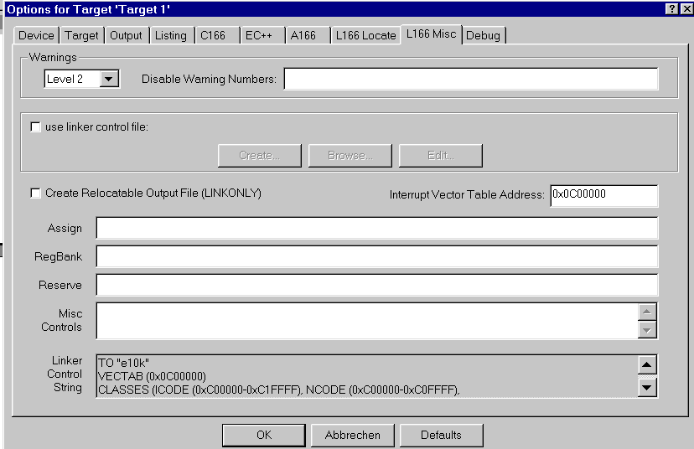

Debug (do nothing)

OK

- Step: Insert your application specific program:

double click MAIN.C and insert Global Variables:
char menu[] =
"\r\n\n\n\n"
"1 ... LED P9_P4 ON\r\n"
"2 ... LED P9_P4 OFF\r\n"
"3 ... LED P9_P4 blinking\r\n"
" \r\n";

char question[] =
"your choice: ";

char message1[] =
"\n\r*** LED is ON ***\r\n";

char message2[] =
"\n\r*** LED is OFF ***\r\n";

char message3[] =
"\n\r*** LED is BLINKING ***\r\n";

int wait=3;
bit blinking=ON;
char select=' ';

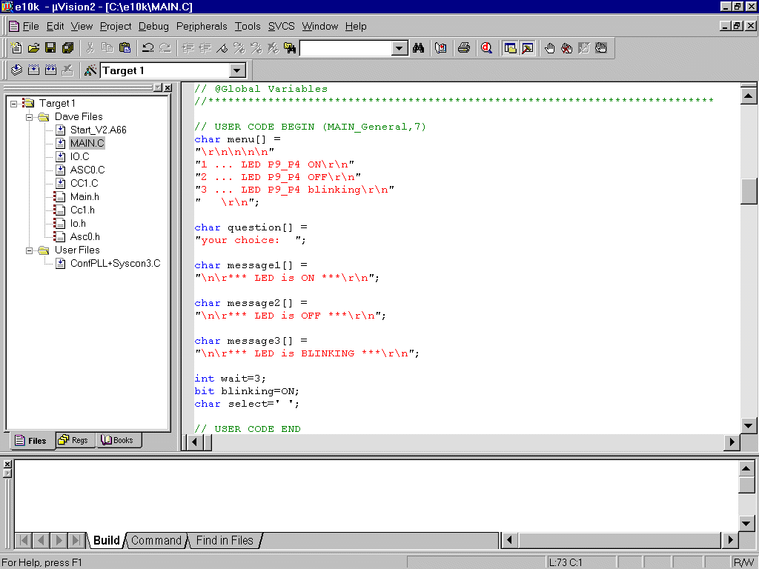
insert the function input()

char input (void)
{
char in=' ';
do
{
printf(question);
while (!ASC0_RIC_IR) _nop_();
ASC0_RIC_IR=0;
in = ASC0_RBUF;
}while (in!='1' && in!= '2' && in != '3');
return in;
}

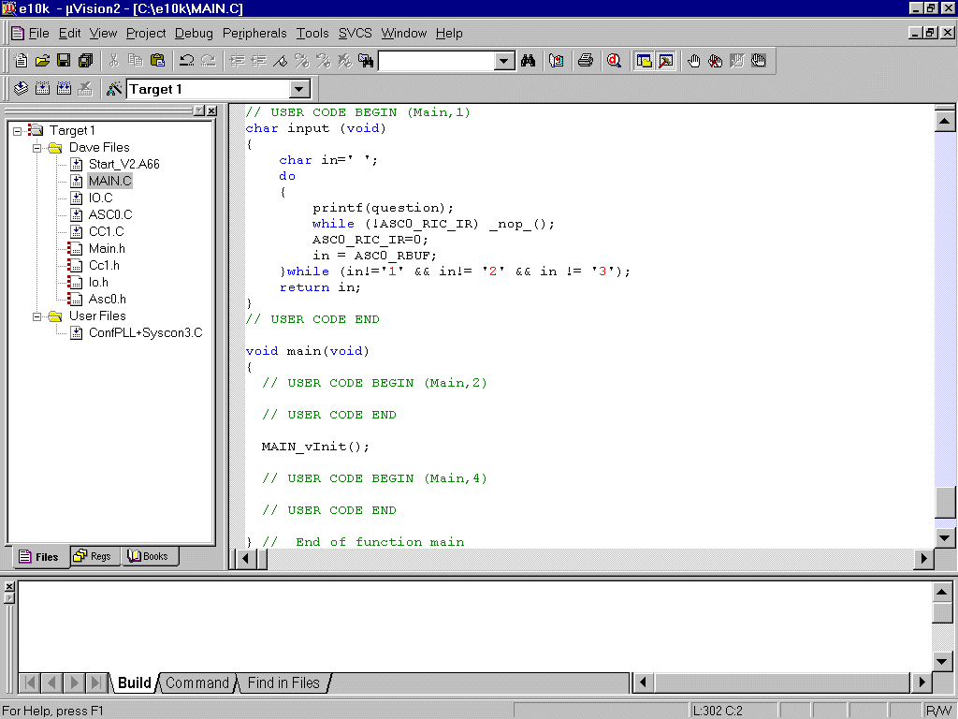

insert the following code in the main function:

Configure_PLL();
Configure_SYSCON3();

while(wait);
while (1)
{
printf(menu);
select=input();

switch (select)
{
case '1': blinking=OFF; P9_P4=LEDON, printf(message1); break;
case '2': blinking=OFF; P9_P4=LEDOFF, printf(message2); break;
case '3': blinking=ON, printf(message3); break;
}
}

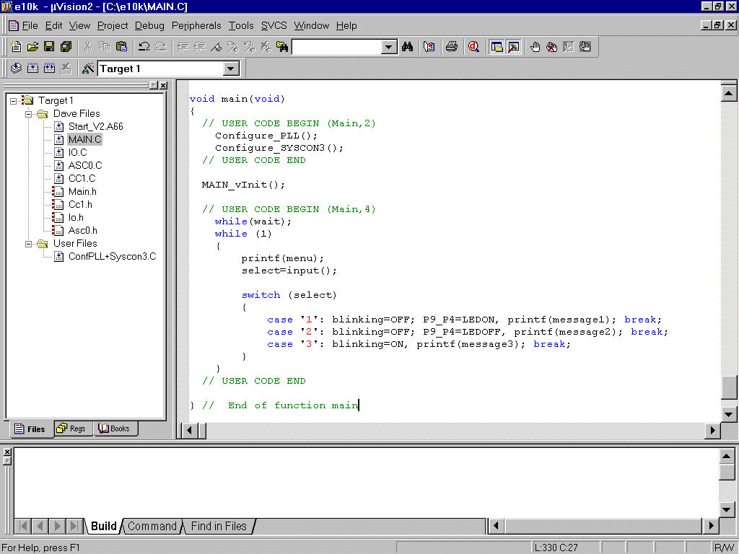
double click Main.h and insert the following Defines:

#define OFF 0
#define ON 1
#define LEDON 0
#define LEDOFF 1

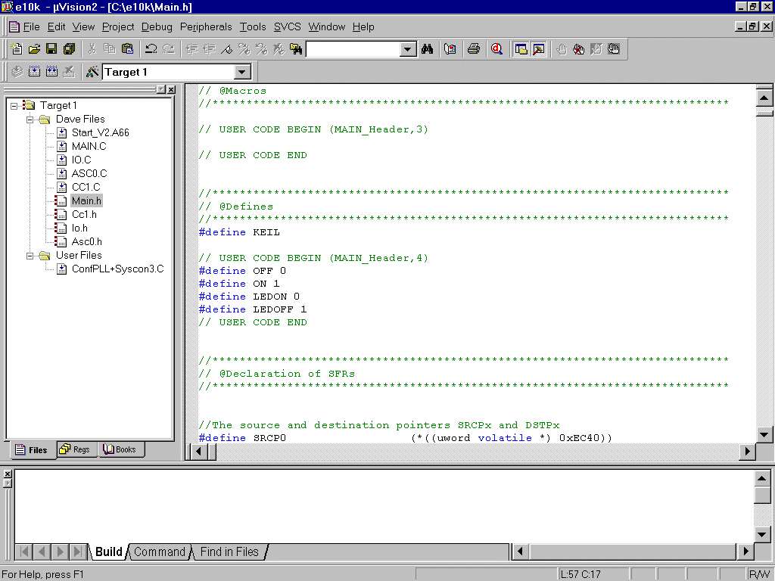

insert Global Variables

extern bit blinking;
extern int wait;

insert Prototypes

extern void Configure_PLL (void);
extern void Configure_SYSCON3 (void);

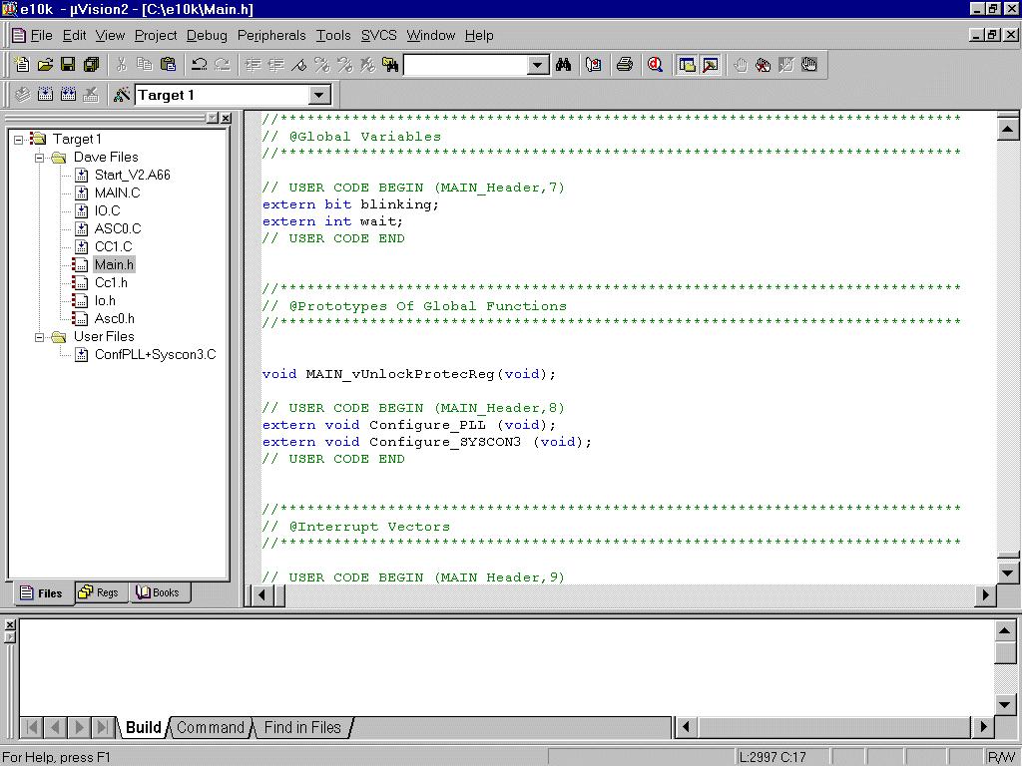

insert Includes (for printf() )

#include <stdio.h>
#include <ctype.h>

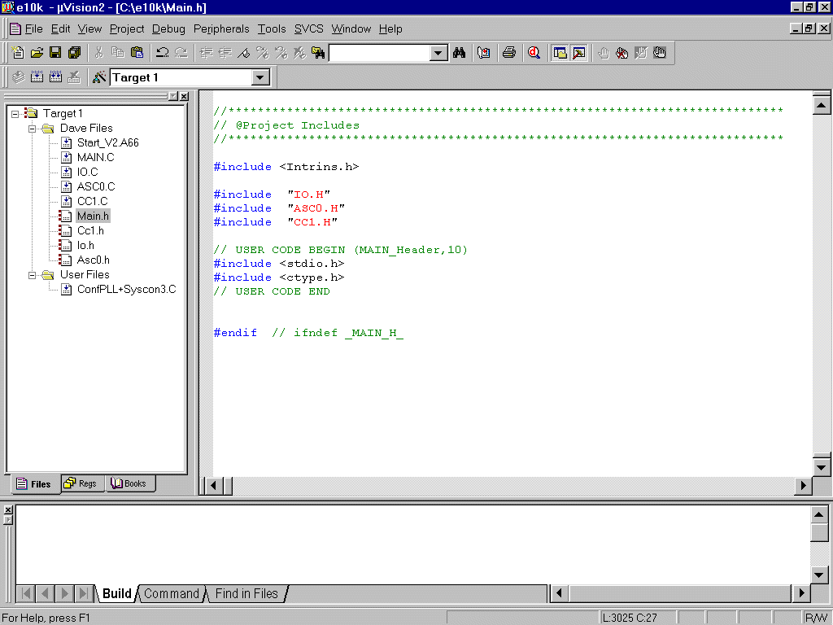

double click ASC0.C

insert in the ASC0_vInit() function: (to start printf() )

ASC0_TIC_IR=1;

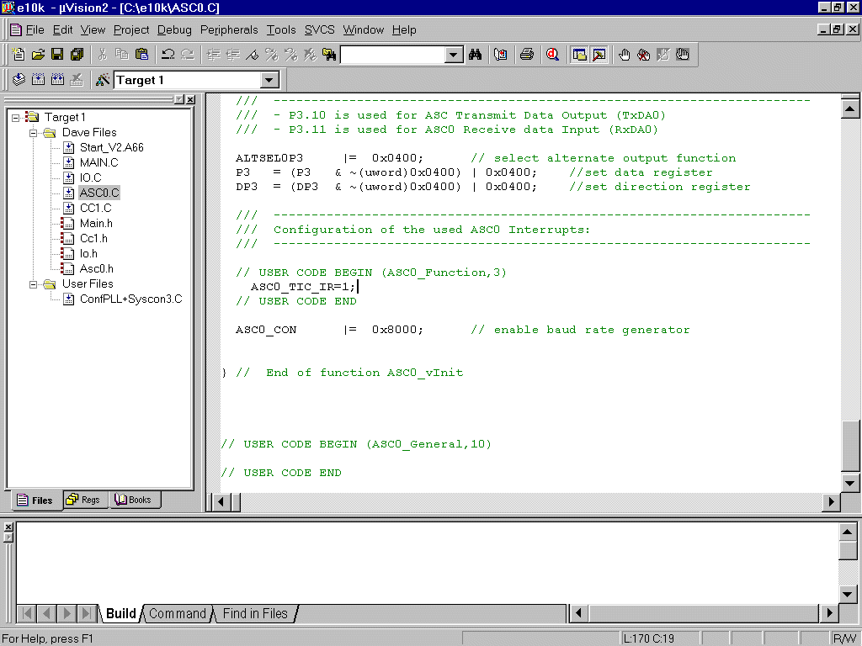
double click CC1.C

insert code for T0 interrupt service routine:

if(wait)
wait--;

if(blinking)
P9_P4=~P9_P4;

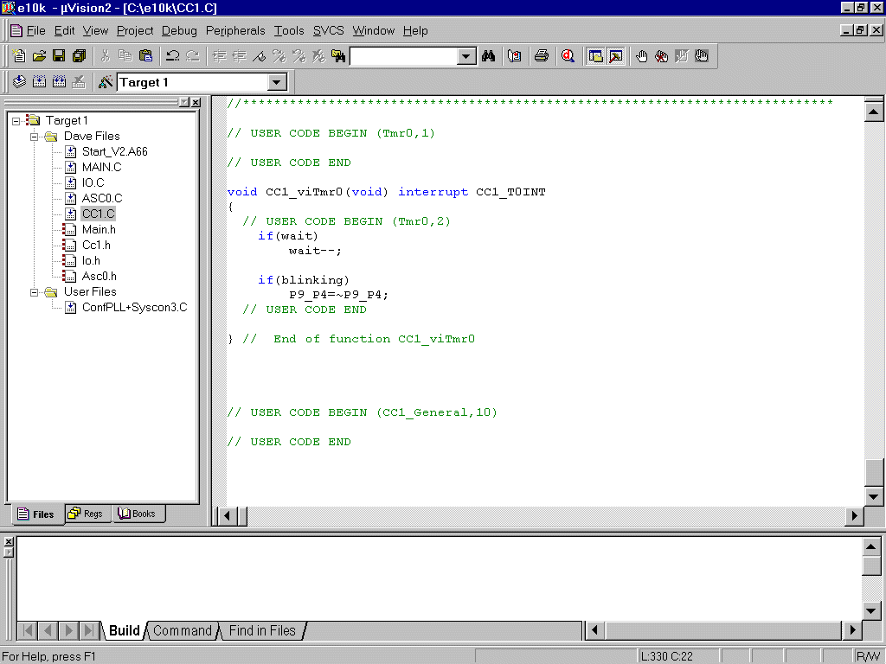

- Step: Generate your application program – generate the hex file for Memtool:

Project
Rebuild all target files

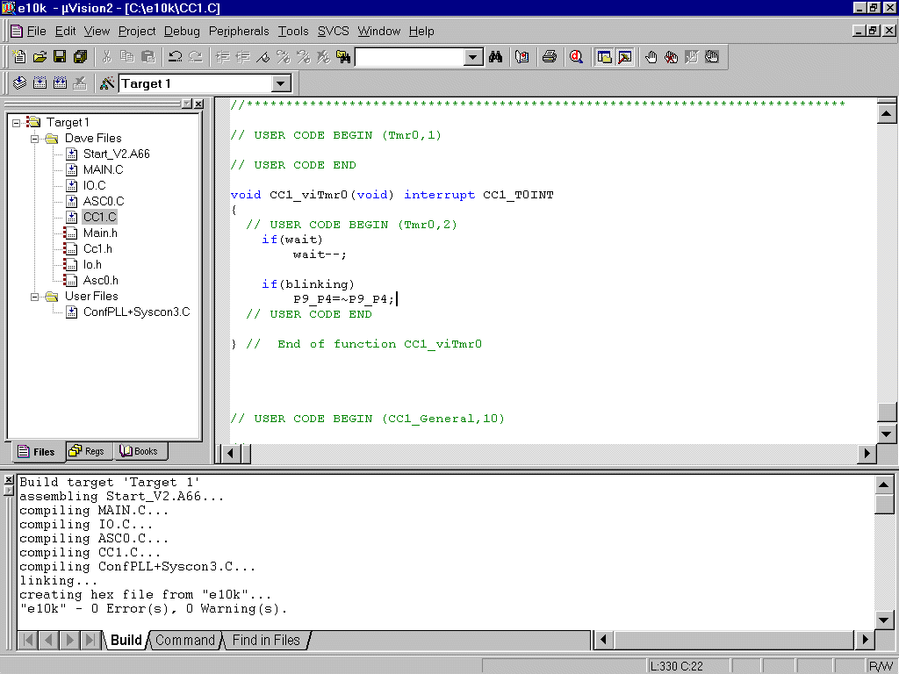

Now you can close your project and µVision 2:

Project
Close Project

File

Exit

Now you can program the hex output file e10k.H86 with Memtool in the OnChipFlash (Program Memory) of the XC164CS microcontroller.
- Step: using the simulator:

The uVision2 simulator has a couple of VTREG's that allow you the
configuration of the reset behaviour. These pins of the Infineon XC16x are
reflected by the following VTREGs:

EA is the EA pin (0:= code fetch from external ROM ; 1:= code fetch from on-chip ROM)
ALE is the ALE pin
RD is the RD pin
WR is the WR pin
RSTCFGP are the levels on the configuration PINs
NMIPIN is the NMI pin

By default, the value of the EA pin is set to 0 to simulate the off-chip
ROM. When this VTREG is 1 at CPU reset, the uVision2 simulates on-chip ROM
and the RESET vector and interrupt vectors are at address 0xC00000.

You can enable the on-chip ROM behaviour as described below:

1. Create a debugger INI file that contains the following commands:

EA = 1 /* Start execution from on-chip ROM */
reset /* perform CPU reset: uses value at EA */
g, main /* execute program til main */

2. Under Options for Target - Debug - Use Simulator, disable the option "Go
till main ()" then enter the filename for the debugger INI file you created.

Start Keil µVision and open the Keil Project

If you see an open project – close it: Project - Close Project

Project - Open Project
choose: C:\e10k
choose: File type: Project Files (*.uv2)
choose: e10k.Uv2

Open

File – New

insert:

EA = 1 /* Start execution from on-chip ROM */
reset /* perform CPU reset: uses value at EA */
g, main /* execute program til main */

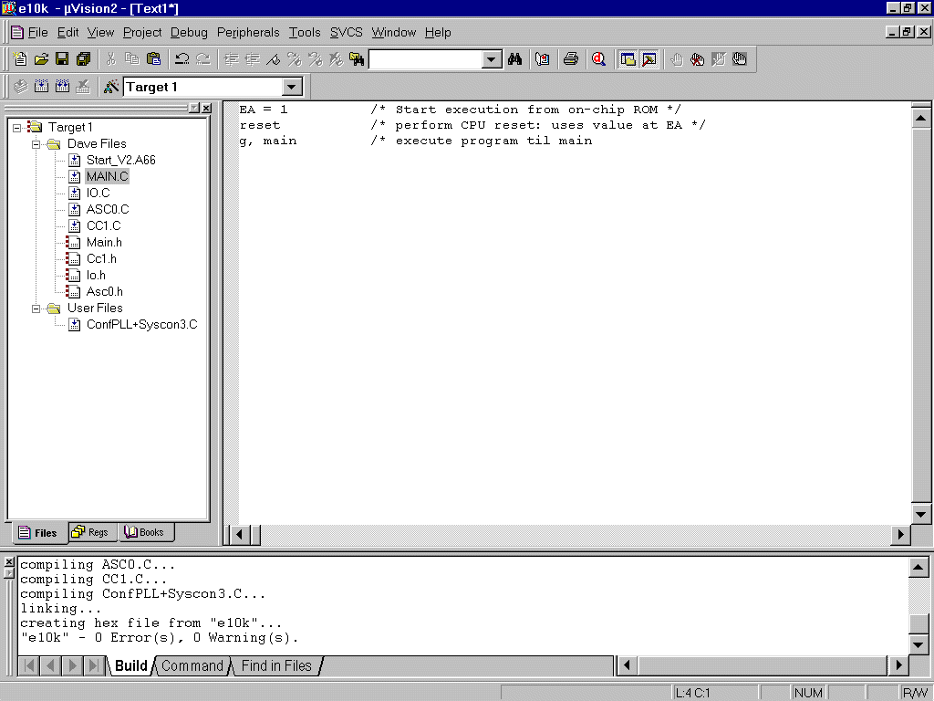

File – Save As...

choose: C:\e10k

Dateiname/Filename: simulator.ini

Speichern/Save

... include the simulator.ini File

mouse position: Files window: User Files: click right mouse button

Add Files to Group ´User Files‘
input filename *.ini
mark simulator.ini

Add
choose: Type: Custom file

OK
Close

... configure the Options for the Simulator Ini-File:

Files window: right mouse button click simulator.ini

Options for File simulator.ini
click □ Include in Target Build
click □ Always Build
click □ Link Publics Only

OK
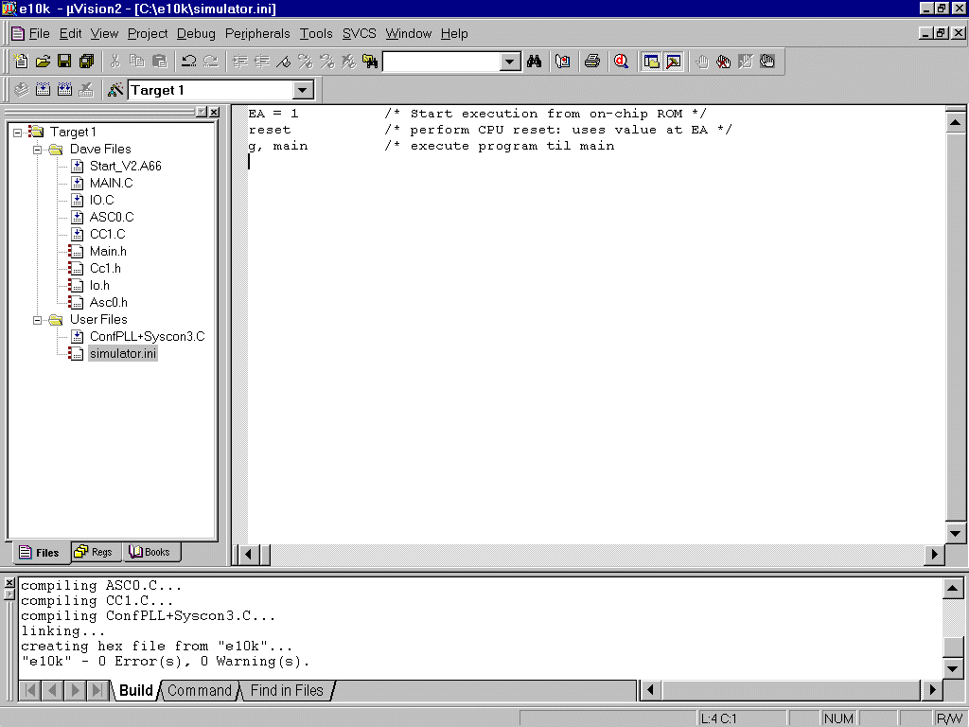

... configure Simulator – Control:

right mouse button (Files window) click Target1

Options for Target ´Target1‘

Debug
disable Go till main
insert Initialization File: simulator.ini

OK
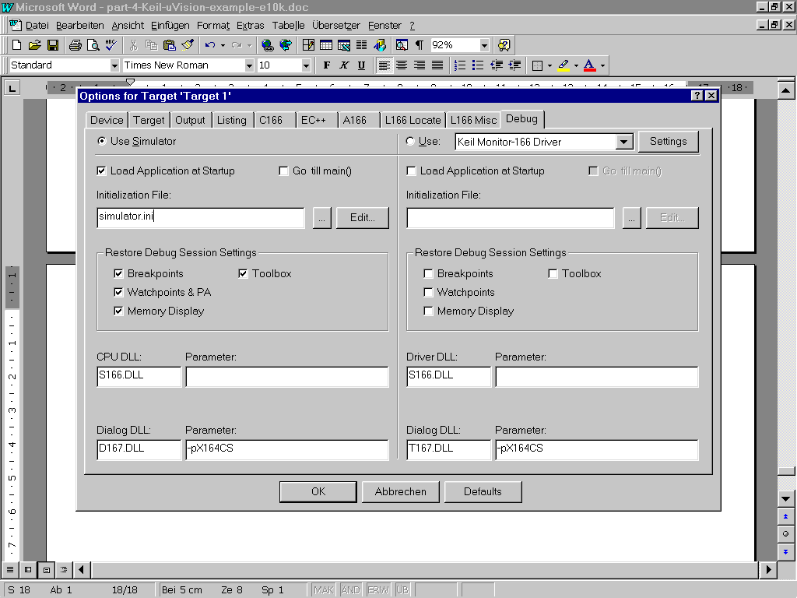

... using the simulator:

Debug
Start/Stop Debug Session
Debug
Go

View
Periodic Window Update

View
Serial Window #1
additionally – if you do not see the Serial Window #1:
View
Serial Window #1

Peripherals
I/O-Ports
Port9

Peripherals
Capcom1 (T0,T1)
T0
